**Ideation Phase**

**Define the Problem Statements**

|  |  |
| --- | --- |
| **Date** | 29 June 2025 |
| **Team ID** | LTVIP2025TMID59837 |
| **Project Name** | Hematovision: Advanced Blood Cell Classification using Transfer Learning |
| **Maximum Marks** | 4 Marks |

**Customer Problem Statement Template:**

Medical professionals including hematologists, pathologists, laboratory technicians, and healthcare providers, especially in hospitals, diagnostic labs, and rural health centers. The manual classification of blood cells under a microscope is time-consuming, error-prone, and requires expert interpretation. In many regions, there is a shortage of skilled professionals, and early diagnosis of blood-related diseases (like leukemia or anemia) often gets delayed due to limited access to reliable diagnostic tools. The primary goal is to automate and enhance the process of blood smear analysis, which is critical for diagnosing a range of conditions such as leukemia, anemia, infections, and other hematologic disorders. To enhance real-world applicability, the model can be integrated into a web or mobile application, allowing technicians or clinicians to upload microscope images and receive instant analysis and classification results.

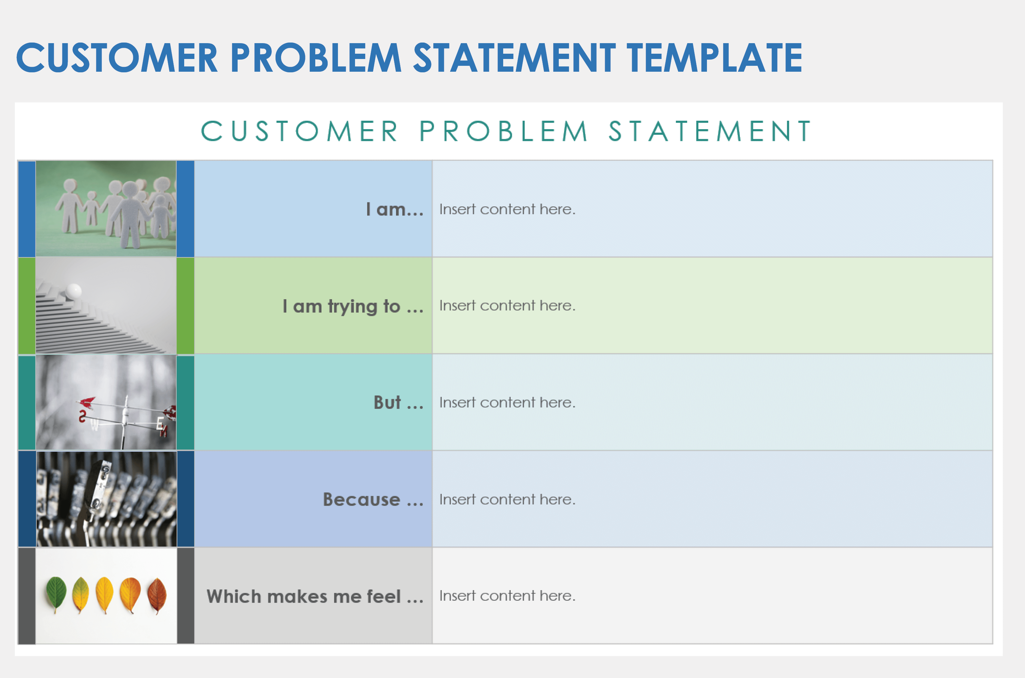

**Example:**

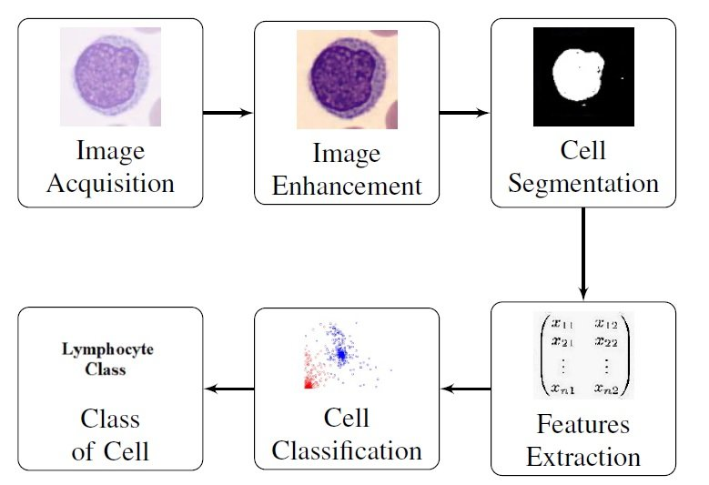

|  |  |  |  |  |  |
| --- | --- | --- | --- | --- | --- |
| **Problem Statement (PS)** | **I am (Customer)** | **I’m trying to** | **But** | **Because** | **Which makes me feel** |
| PS-1 | Healthcare professional working | accurately classify different types of blood cells from microscope | manual process is time-consuming, requires a high level of expertise | we lack access to automated, intelligent tools that can assist with precise | overwhelmed, under-resourced |
| PS-2 | Junior lab technician | to learn and correctly classify different types of blood cells | I struggle with identifying subtle differences between cell types, especially when under pressure or dealing with abnormal samples | the process is complex and subjective, and I don’t always have immediate access to expert guidance | unsure, stressed, and afraid of making diagnostic mistakes that could impact patient care. |